The City School – Educational Technology Department

Aims+ User Manual

For HO Guidance

Contents

Introduction 3

Advantages of Aims+ 3

Overview 4

Setup 6

Evaluation Criteria Center 6

Assign / UN assign Student 7

Achievement Rating 8

Assign Grading To Class 9

Evaluation Criteria Percentage 10

Performance Evaluation Labels 11

Result Grade Management 12

Term Evaluation Criteria 13

Subject Wise Item Head 14

Activity Skill Management 15

TCS Reports 17

Non Academic Report 🡪 Non Academic Reports (HO, RO & CO) 17

Academic Report 🡪 Academic Reports (HO, RO & CO) 18

TCS Reports 🡪 A/O Level Reports 19

Results 19

Result Card 19

Search 20

Attendance 21

Attendance 🡪 Attendance Type 21

Attendance 🡪 Day Type 22

Help Desk 22

Help Desk 🡪 Complaint Category 22

Archive 23

Archive 🡪 Archive Reports 23

Archive 🡪 Term Archive Process 23

Manage Resource 24

Mange Resources 🡪 Academic Resources (Down) 24

Mange Resources 🡪 General Resources (Down) 25

Mange Resources 🡪Campus Drop Box 26

Mange Resources 🡪Academic Recourse Category 27

Progress Checker 28

Progress Checker 🡪 Progress Checker 28

Progress Checker 🡪 Manage Center Access 29

# Introduction

AIMS+ is an advanced version of idealAims to manage student data. Academic Student Information Systems (Aims+) provide capabilities for entering student test and other assessment scores, build student schedules, track student attendance, and manage many other student-related data needs in a school.

## Advantages of Aims+

* Aims+ Management System turns your manual means of results into digital form over an online hosting platform.
* Archives your school results from the very date you start using it.
* Automatically computes cumulative scores and grades according to figures being keyed in.
* Helps you to call-up a particular student’s result at any point in time.
* Rates your school higher than your competitors.
* Reduces the rate of human errors. E.g. Mis-calculation of cumulative scores.
* Automatically awards remarks to student based on grades.
* Parents and guardians can have access to their ward’s results/performance is school. This helps to put such a student in check.

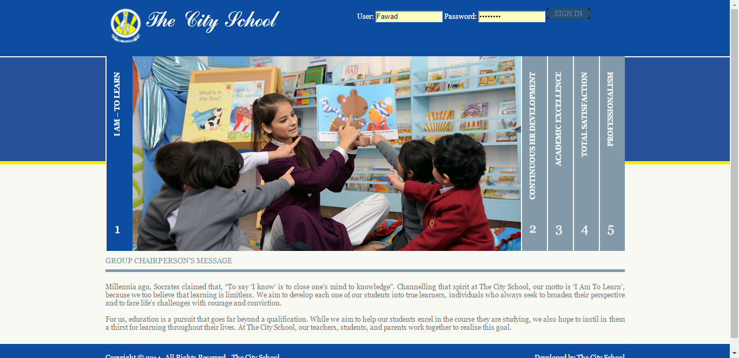

# Overview

1. Setup
2. Reports
3. Result
4. Search
5. Attendance
6. Helpdesk
7. Archive
8. Mange Resources

These main menus contain sub menus to facilitate the Campus Officer.

1. Setup

Setup menu contains three sub menus

* Evaluation Criteria Center
* Assign / Un-Assign Students
* Achievement Rating
* Activities Skill Management
* Assign Performance Grading To Class
* Term Evaluation Criteria Percentage
* Performance Evaluation Labels
* Result Grades Management
* Term Evaluation Criteria
* Subject Wise Item Heads

1. TCS reports

There are two types of reports

* Non Academic Report
* Academic Report
* Welcome Reports
* A/O Level Reports

1. Result

* Result Card

(View result card of a student)

1. Search

HO User can search records using following search options

* Search Student
* Search User
* Search Class
* Search Section
* Search Subject

1. Attendance

HO User can enter the attendance of students according to Class Section Wise and have following options

* Calendar
* Student Attendance

1. Helpdesk

HO User can use Helpdesk have following option

* IT Helpdesk
* Complaint Category
* Helpdesk resource.

1. Archive

HO User can see following archive reports

* Archive Reports
* Term Archive Process

1. Mange Resources

HO User has also rights to manage resources

* Academic Resource (Download)
* Academic Resource Category
* General Resource (Download)
* Campus Drop Box

1. Progress Checker

HO User has also rights to manage progress checker

* Progress Checker
* Manage Center Access

# Setup

## Evaluation Criteria Center

Setup 🡪 Evaluation Criteria Center

1. Click on the **Setup** and then click **Evaluation Criteria Center**.
2. Here HO User can assign Evaluation Criteria Center (for A/O Level).

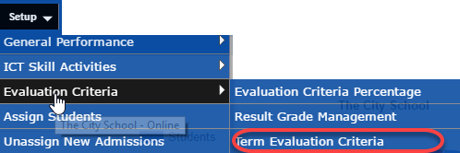

HO User will select

Region🡪Center🡪Class 🡪 Section and Subject

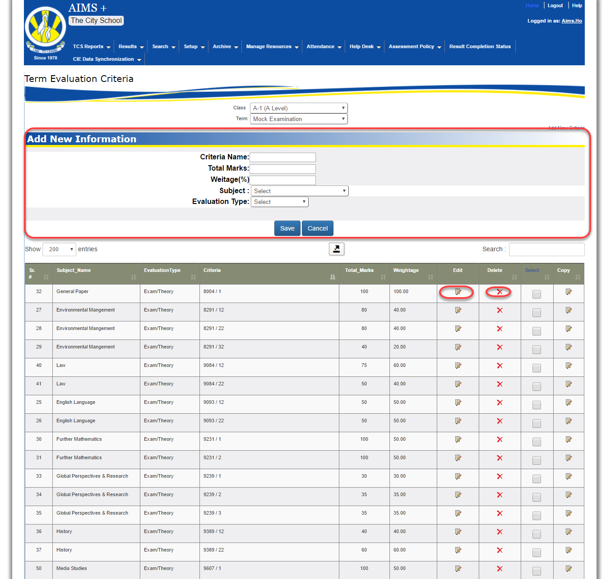

Using This Screen HO user can manage evaluation criteria according to Class, Subject and term wise which is necessary for result generation.

## Assign / UN assign Student

Setup 🡪 Assign / UN assign Student

1. Click on the **Setup** and then click **Assign / Un Assign Student**.
2. Here HO User can assign/un-assign students of a class to section.

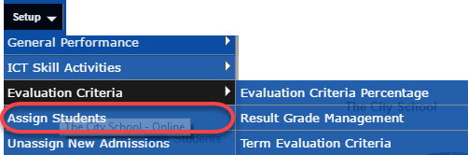

Select Status (Approved/Un assigned and assigned) 🡪 Class available🡪section

Student’s information will appear in below form

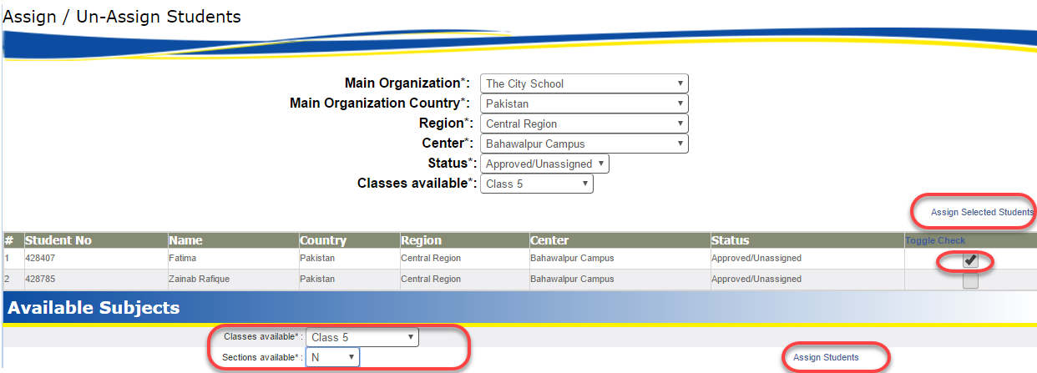

Then after checking the toggle check of desired student following screen will appear

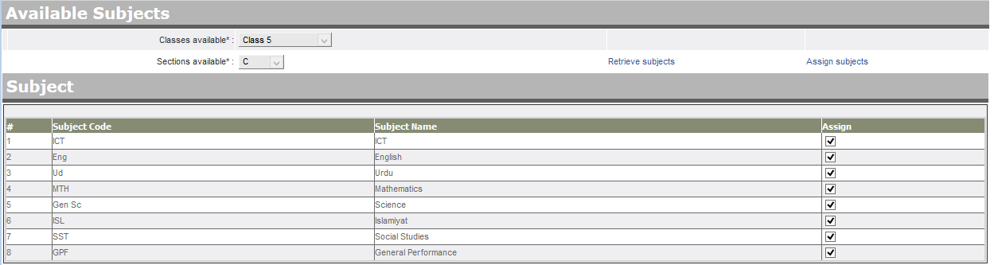

Now Ho user can assign / UN Assign the subjects.

## Achievement Rating

Setup 🡪 Achievement Rating

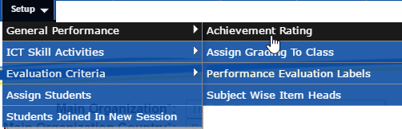

Using this screen HO User can manage achievement rating for students

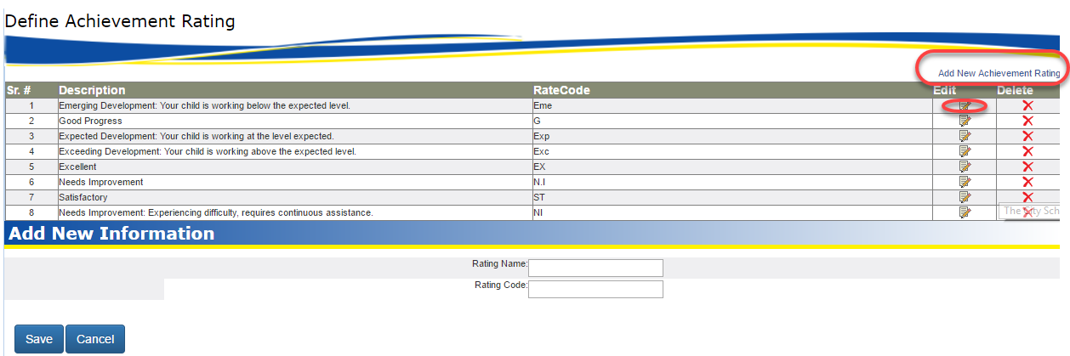

## Assign Grading To Class

Setup 🡪 Assign Grading to Class

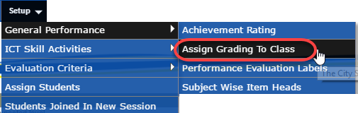

HO User can assign grading to class after selecting the class from dropdown

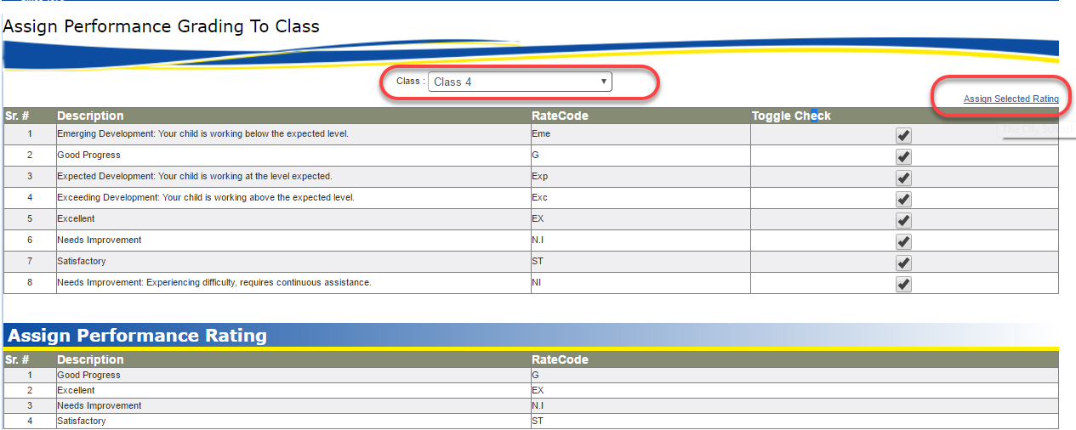

## Evaluation Criteria Percentage

Setup 🡪 Evaluation Criteria Percentage

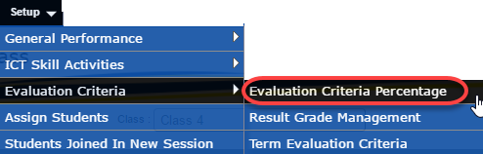

HO User can define Evaluation Criteria Percentage

HO User will select

Class 🡪Subject and Term

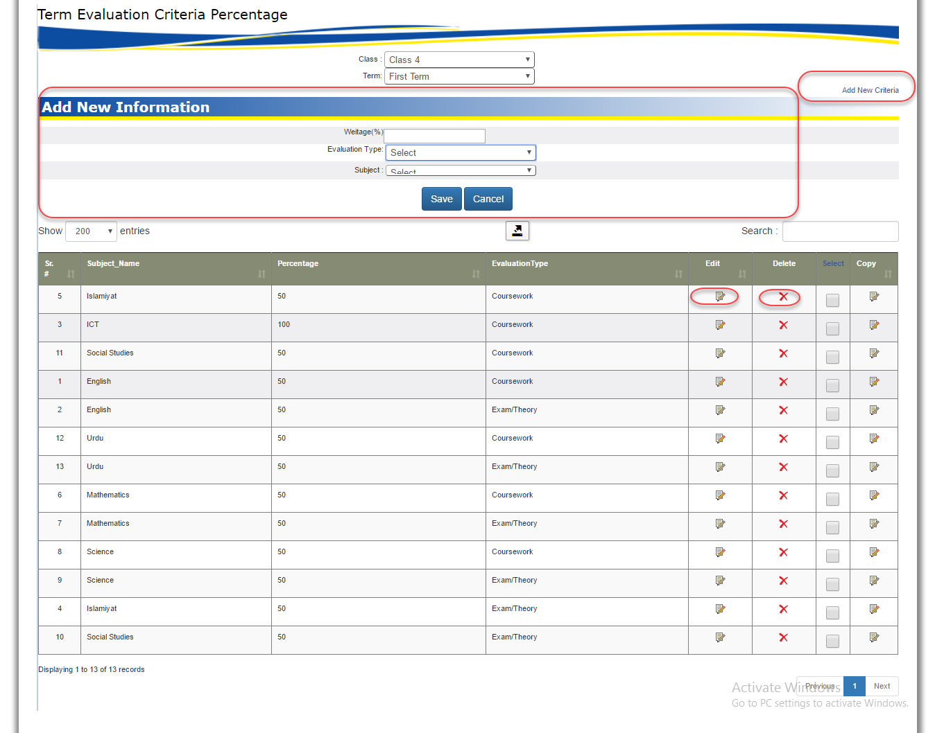

Then user can easily defined each criteria with weightage and evaluation type.

## Performance Evaluation Labels

Setup 🡪 Performance Evaluation Labels

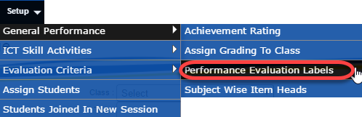

HO User can define Performance Evaluation for junior class

HO User will select

Class 🡪Subject and Term

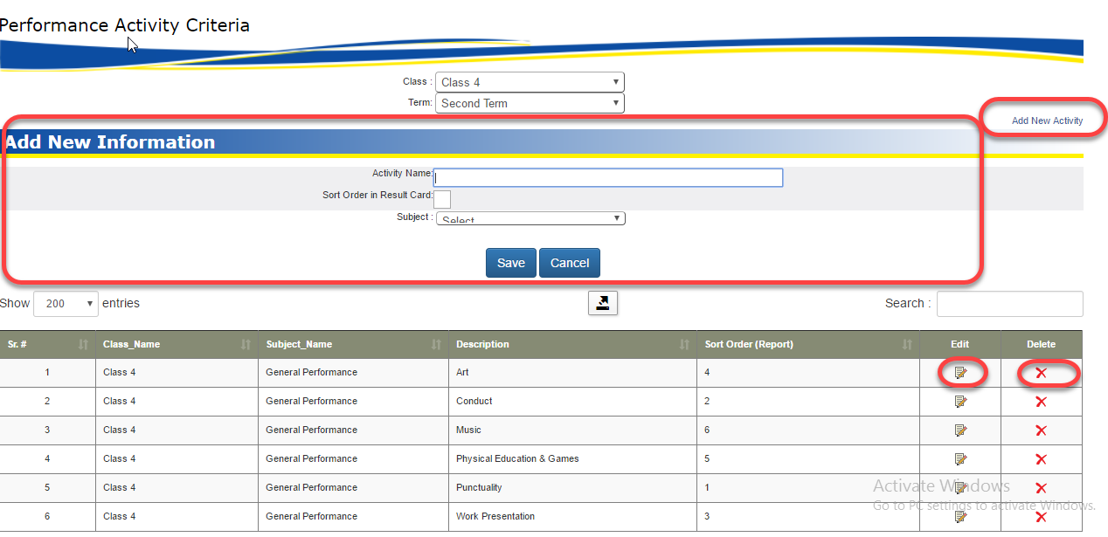

These activates are necessary for junior class student evaluation.

## Result Grade Management

Setup 🡪 Result Grade Management

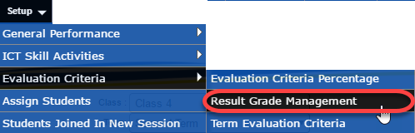

HO User can define Result grades

HO User will select class

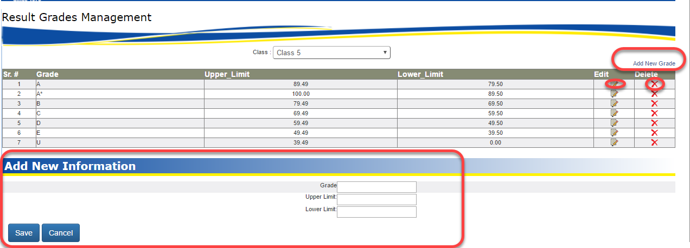

Then HO User can manage all grades class wise.

## Term Evaluation Criteria

Setup 🡪 Term Evaluation Criteria

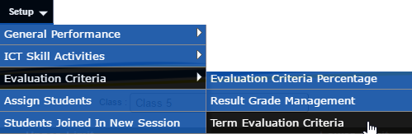

HO User can define Term Evaluation Criteria

HO User will select

Class 🡪Subject and Term

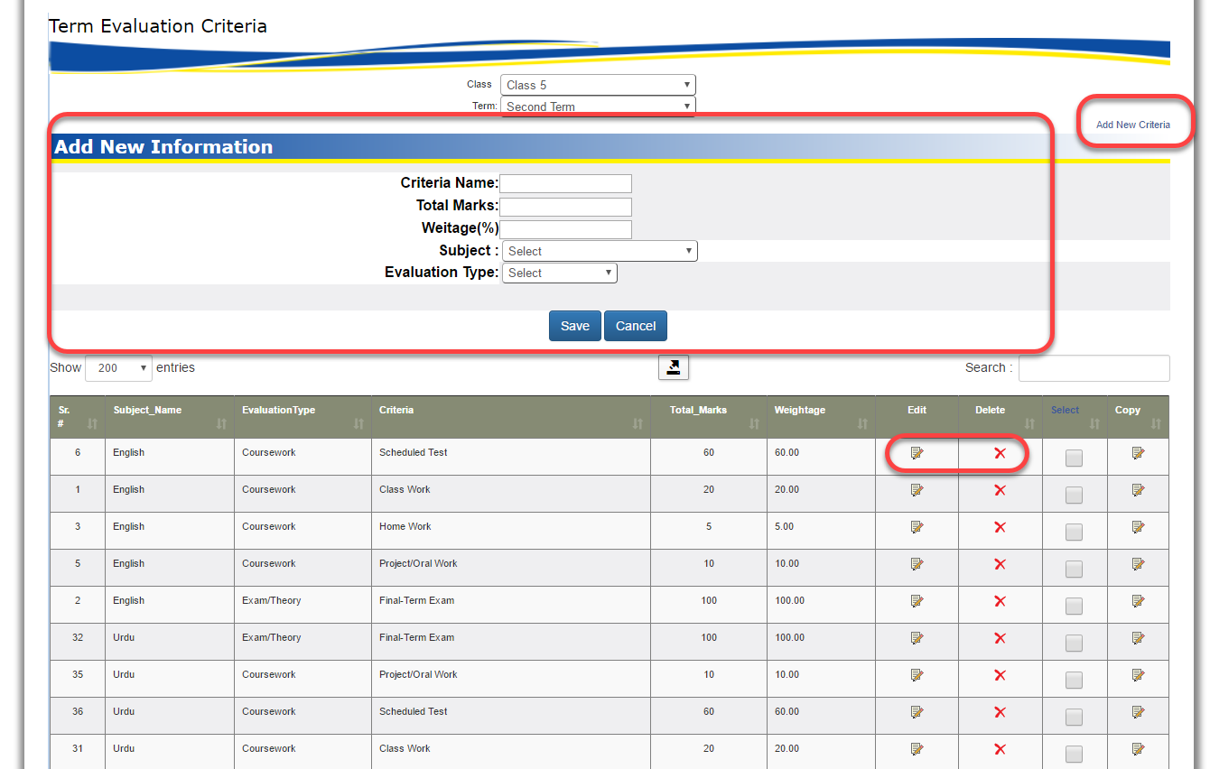

Using this option user can define all the criteria which is necessary to maintain results.

## Subject Wise Item Head

Setup 🡪 Subject Wise Item Head

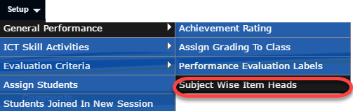

HO User can define Subject wise item heads

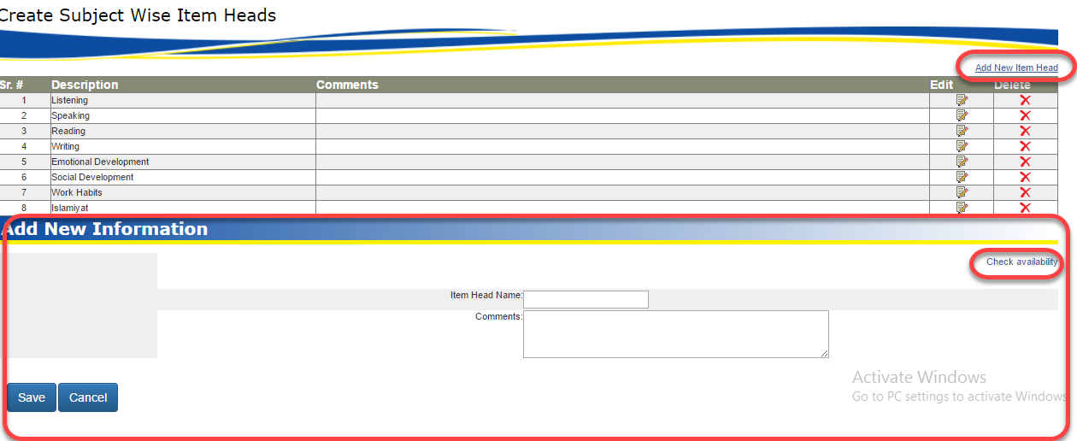

## C:\Users\KHADIJ~1.MEH\AppData\Local\Temp\SNAGHTML127edef.PNGActivity Skill Management

Setup 🡪 Activity Skill Management

HO User will select

Class 🡪Subject and Term

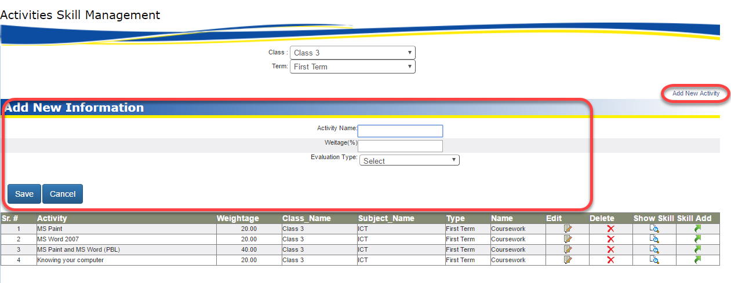

Then user can maintain main activities with weightage and evaluation type wise

Ho user can also maintain Skills for each activity i.e.

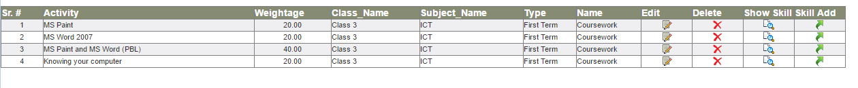

And easily can Add / update records i.e.

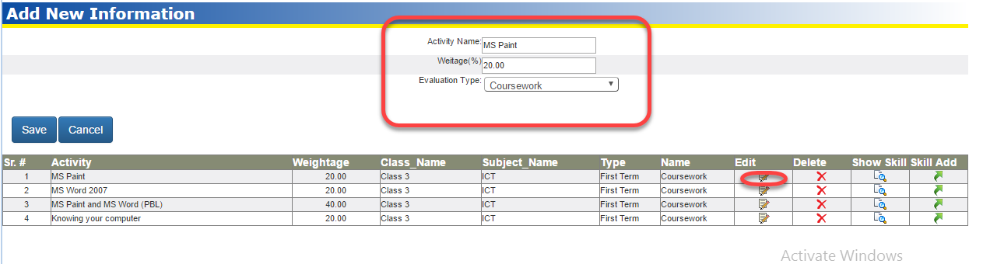

# TCS Reports

## Non Academic Report 🡪 Non Academic Reports (HO, RO & CO)

TCS Reports 🡪 Non Academic Reports 🡪Non Academic Reports (HO, RO & CO)

1. Click on the **TCS Reports 🡪 Non Academic Reports** and then click **Non Academic Reports (HO, RO & CO)**.
2. In this section HO User can view all non-academic reports.

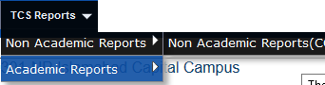

HO User will select

Main Organization🡪Main Organization Country🡪Region🡪Center🡪Session🡪Class and Section

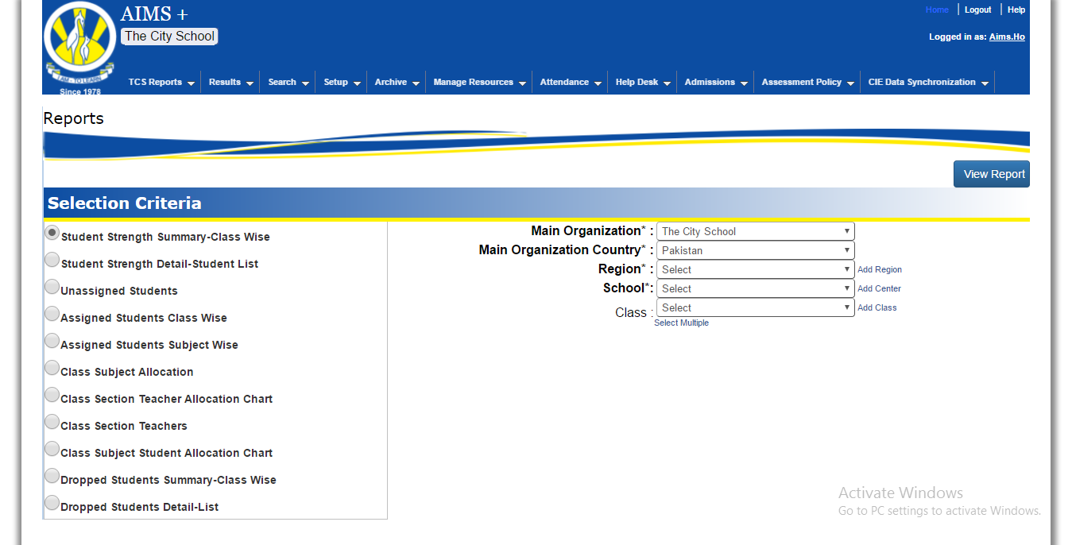

This Screen have following reports

* Student Strength Summary – Class Wise
* Student Strength detail – Student List
* Unassigned Students
* Assigned Students Class Wise
* Assigned Students Subject Wise
* Class Subject Allocation
* Class section Teacher Allocation Chart
* Class Section Teacher
* Class Subject Students Allocation Chart
* Dropped Student Summary – Class Wise
* Dropped Student Detail—list

## Academic Report 🡪 Academic Reports (HO, RO & CO)

(View Academic Reports Center Wise)

TCS Reports 🡪 Academic Reports 🡪 Academic Reports (HO, RO & CO)

1. Click on the **TCS Reports 🡪 Academic Reports** and then click **Academic Reports (HO, RO & CO)**.
2. In this section HO User can view all academic reports.

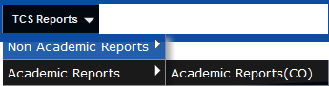

HO User will select

Main Organization🡪Main Organization Country🡪Region🡪Center🡪Session🡪Class 🡪 Section and Subject

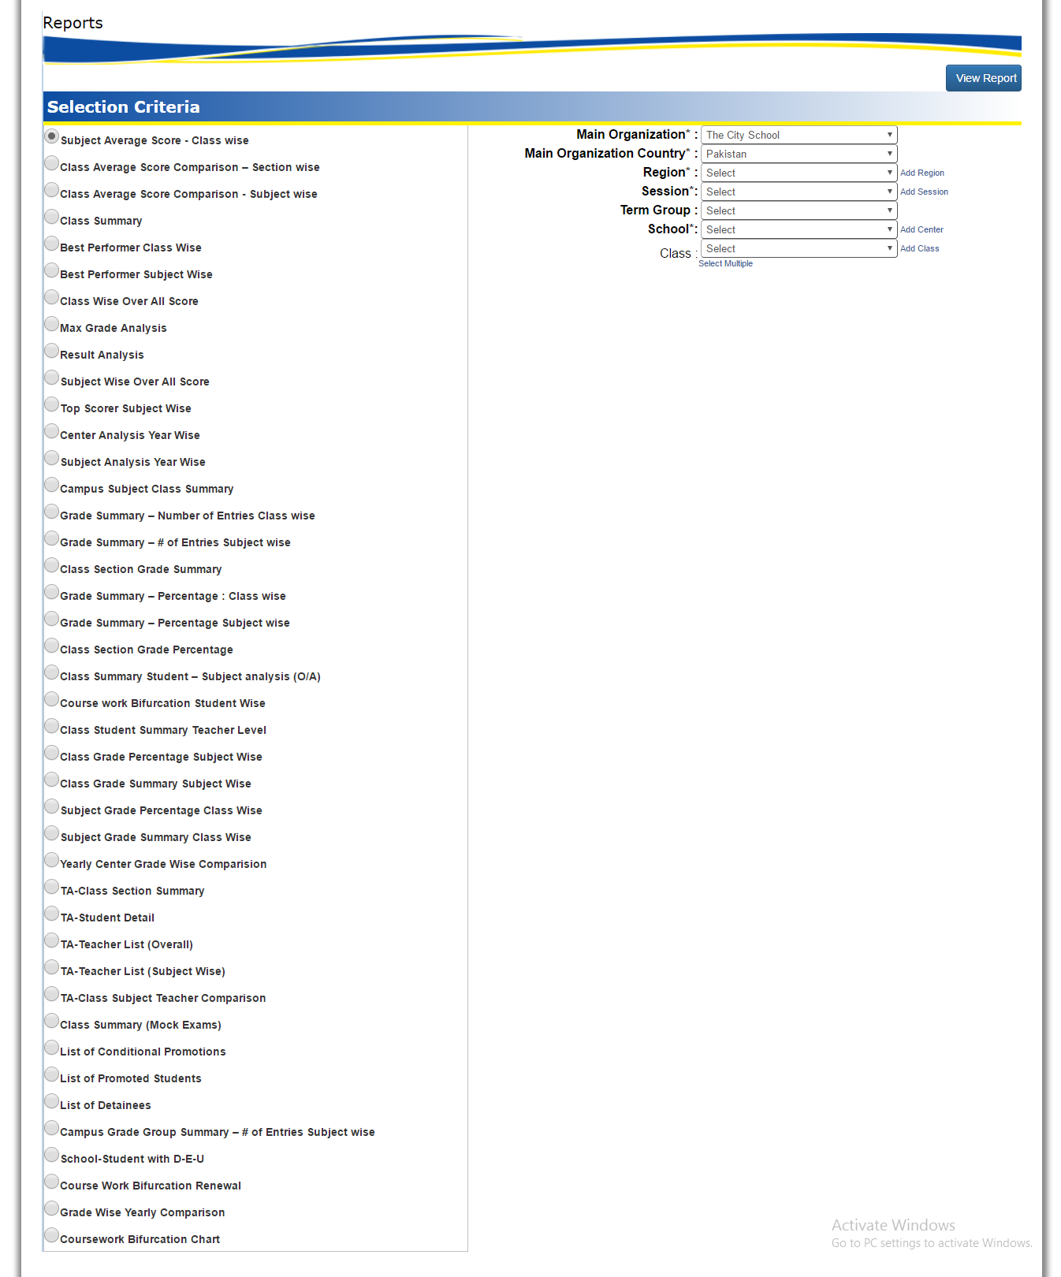

This Screen have following reports

* Class Average Score
* Class section Average Score
* Subject Average Score
* Class Summary

## TCS Reports 🡪 A/O Level Reports

TCS Reports 🡪 A/O Level Reports

1. Click on the **TCS Reports 🡪 A/O Level Reports**
2. In this section HO User can view all academic reports.

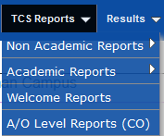

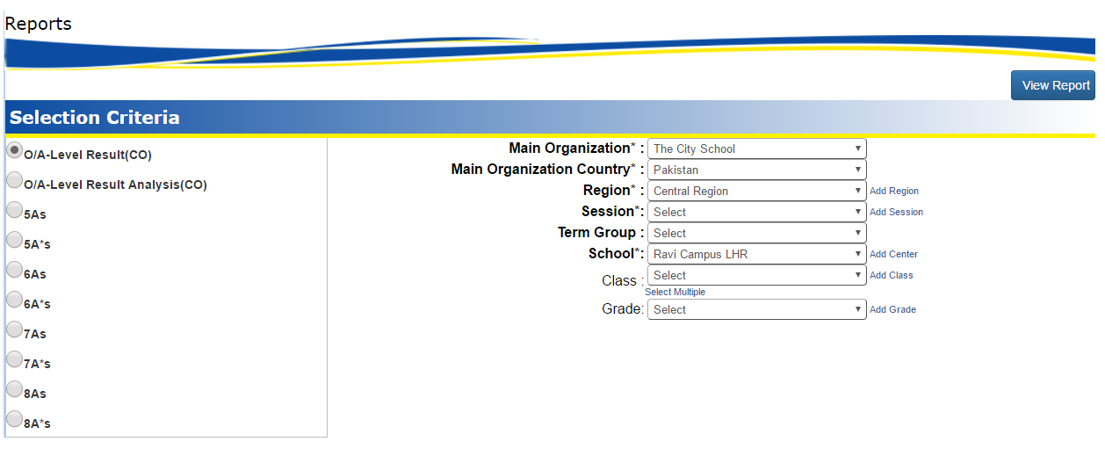

# Results

## Result Card

Results 🡪 Result Card

1. Click on the **Results 🡪 Result Card**
2. In this section HO User can Results.



Select Main Organization🡪Main Organization Country🡪Region🡪Center🡪Session🡪Class 🡪 Section 🡪 Subject and Term

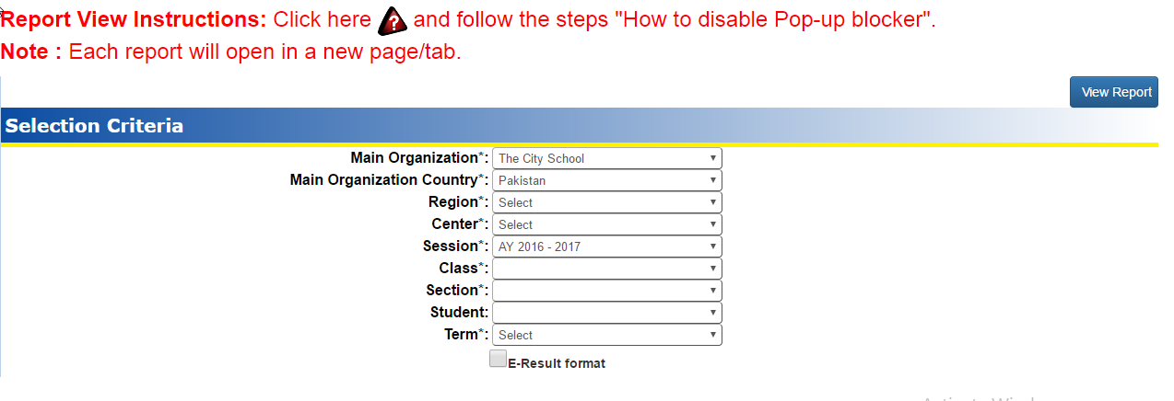

# Search

This system provide facility to search criteria for users and have following categories

**Search** 🡪 **Search Student**

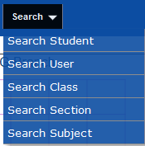

* Search Student
* Search User
* Search Class
* Search Section
* Search Subjects
* Search User With password

HO User can search his desired information by given screen. These screens contains some filters like

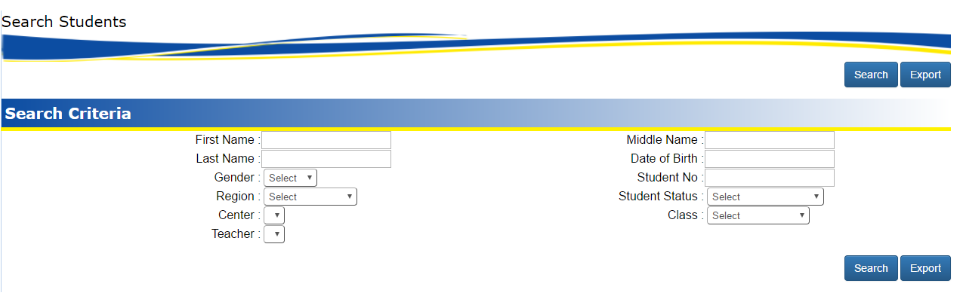

And desired result shown in grid form

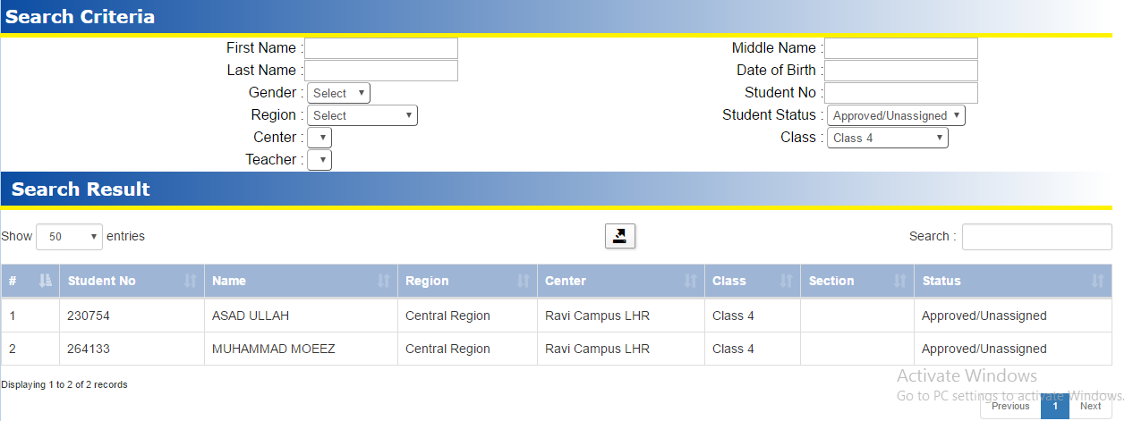

# Attendance

This system provide facility to input student Attendance on class section wise and have following option

## Attendance 🡪 Attendance Type

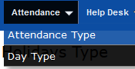

Attendance 🡪 Attendance Type

1. Click on the **Attendance 🡪 Attendance Type**
2. In this section HO User can manage all types of holidays

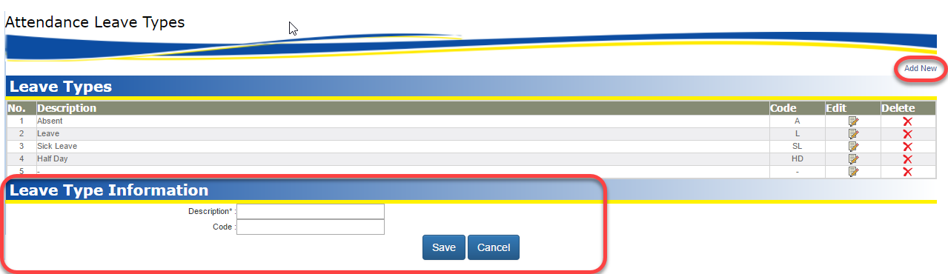

## Attendance 🡪 Day Type

Attendance 🡪 Day Type

1. Click on the **Attendance 🡪 Day Type**
2. In this section HO User can submit Day Type

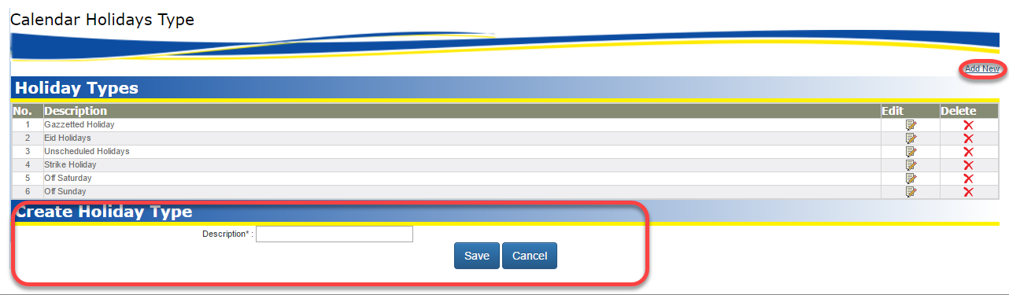

# Help Desk

## Help Desk 🡪 Complaint Category

Help Desk 🡪 Complaint Category

1. Click on the **Help Desk 🡪 Complaint Category**
2. In this section HO User can use complaint box

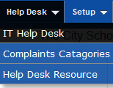

HO User can add update Helpdesk categories.

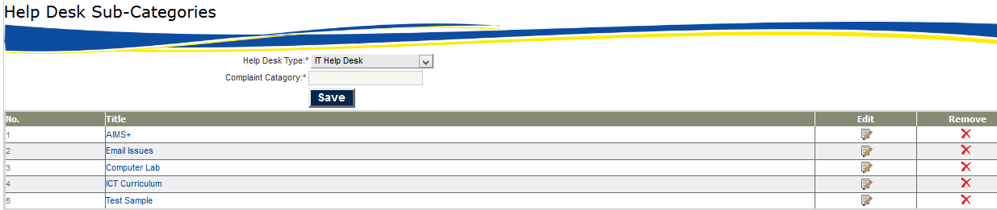

# Archive

## Archive 🡪 Archive Reports

Archive🡪 Archive Reports

1. Click on the **Archive 🡪 Archive Reports**

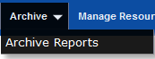

HO User will select

Main Organization🡪Main Organization Country🡪Region🡪Center🡪Session🡪Term

And have following reports

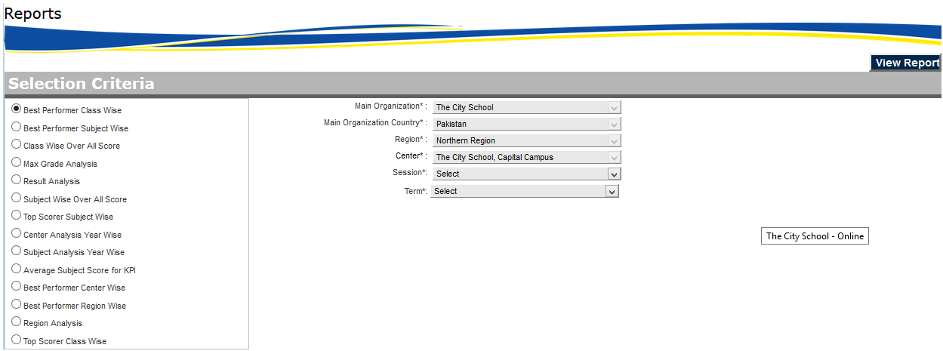

## Archive 🡪 Term Archive Process

Archive🡪 Term Archive Process

1. Click on the **Archive 🡪 Term Archive Process**

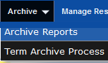

This screen helpful to maintain Archival process

HO User will select

Main Organization🡪Main Organization Country🡪Region🡪Center🡪Session🡪Term

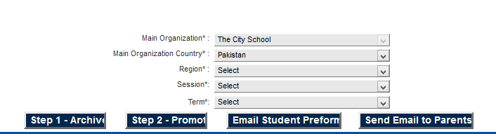

# Manage Resource

This system provide facility to manage electronic material and resources and have following option

## Mange Resources 🡪 Academic Resources (Down)

Manage Resources 🡪 Academic Resources (Down)

1. Click on the **Manage Resources 🡪 Academic Resources (Down)**

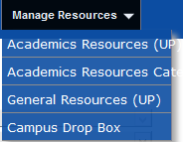

In this section HO User can download class section wise material

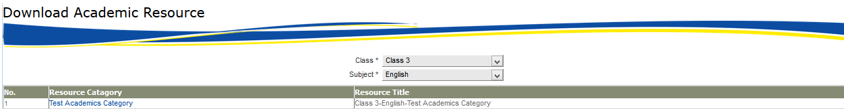

Then after click on desired resource category system will show the share folder where the relevant material has been uploaded

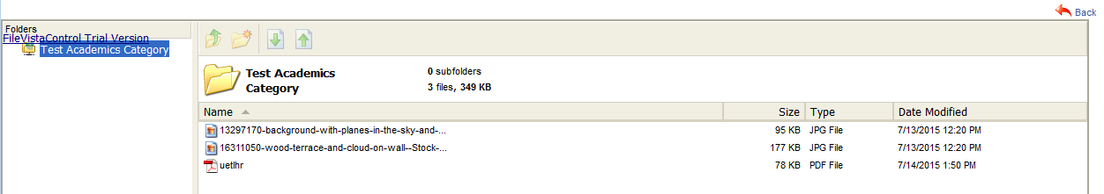

Then HO User can download the relevant material

## Mange Resources 🡪 General Resources (Down)

Manage Resources 🡪 General Resources (Down)

1. Click on the **Manage Resources 🡪 General Resources (Down)**



In this section HO User can download general resources material



Then after click on common resource HO User can download relevant material like this

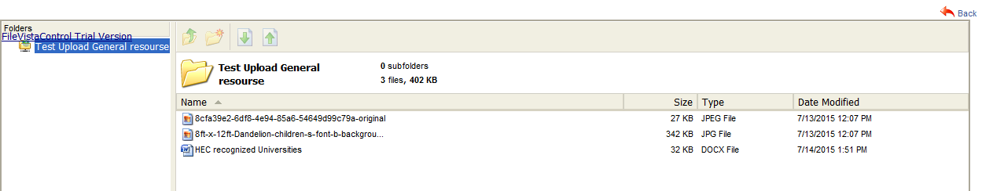

## Mange Resources 🡪Campus Drop Box

Manage Resources 🡪 Campus Drop Box

1. Click on the **Manage Resources 🡪 Campus Drop Box**



In this section HO User has facility to download and upload material

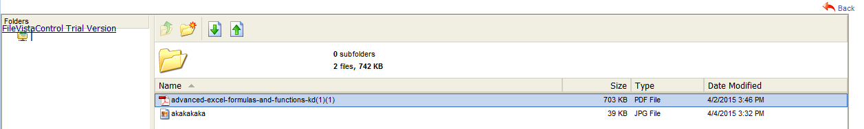

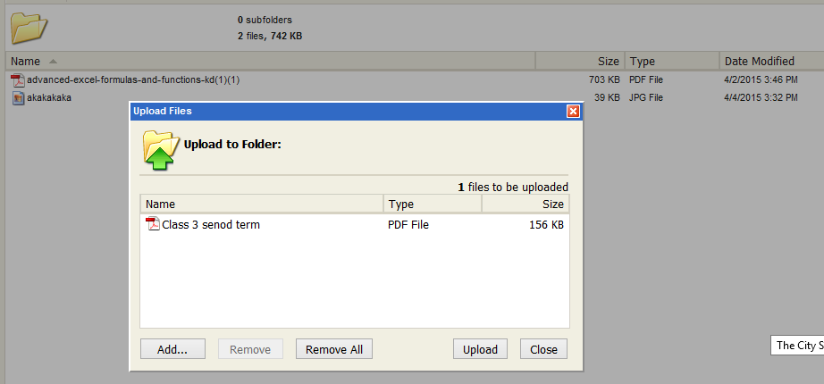

Then after uploading

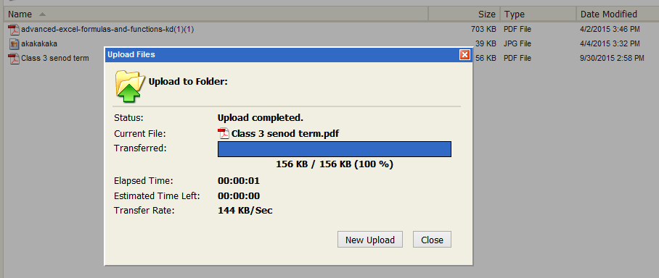

HO User have multiple choices option to upload and download files.

## Mange Resources 🡪Academic Recourse Category

Manage Resources 🡪 Academic Recourse Category

1. Click on the **Manage Resources 🡪 Academic Recourse Category**



HO User can main desired categories

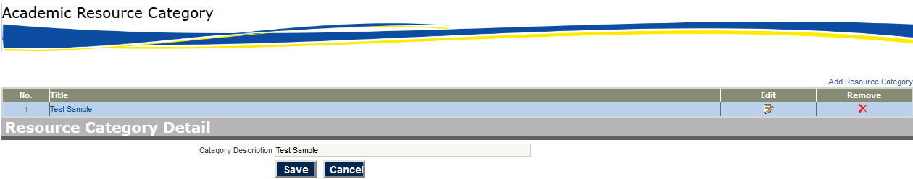

# Progress Checker

This system provide facility to manage Section and Question of progress checker and have following option

## Progress Checker 🡪 Progress Checker

Diagnostic Progress 🡪 TOS Unit & Topics

In this screen you will be adding units.

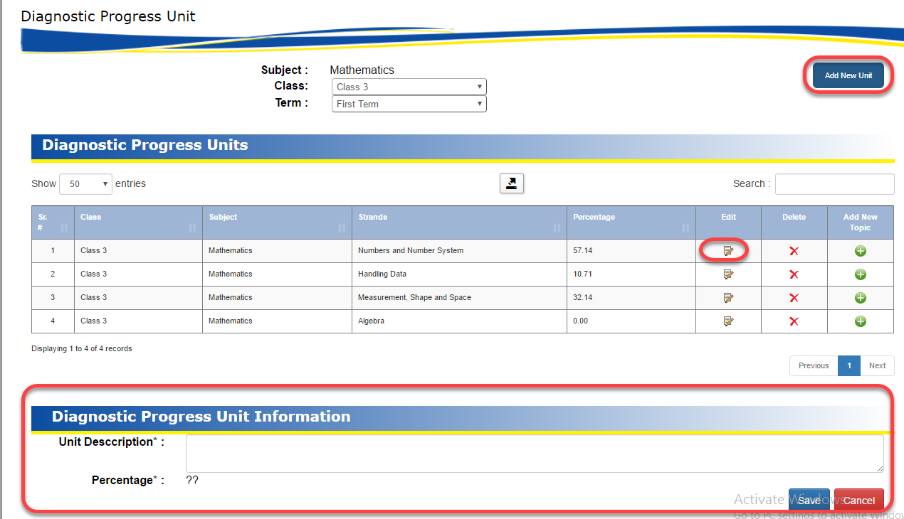

You can edit units after adding them.

Use the Green Plus sign to add topics to the units. You will be redirected to another screen where you can add topics and edit them. The percentage will be calculated on the basis of the weeks.

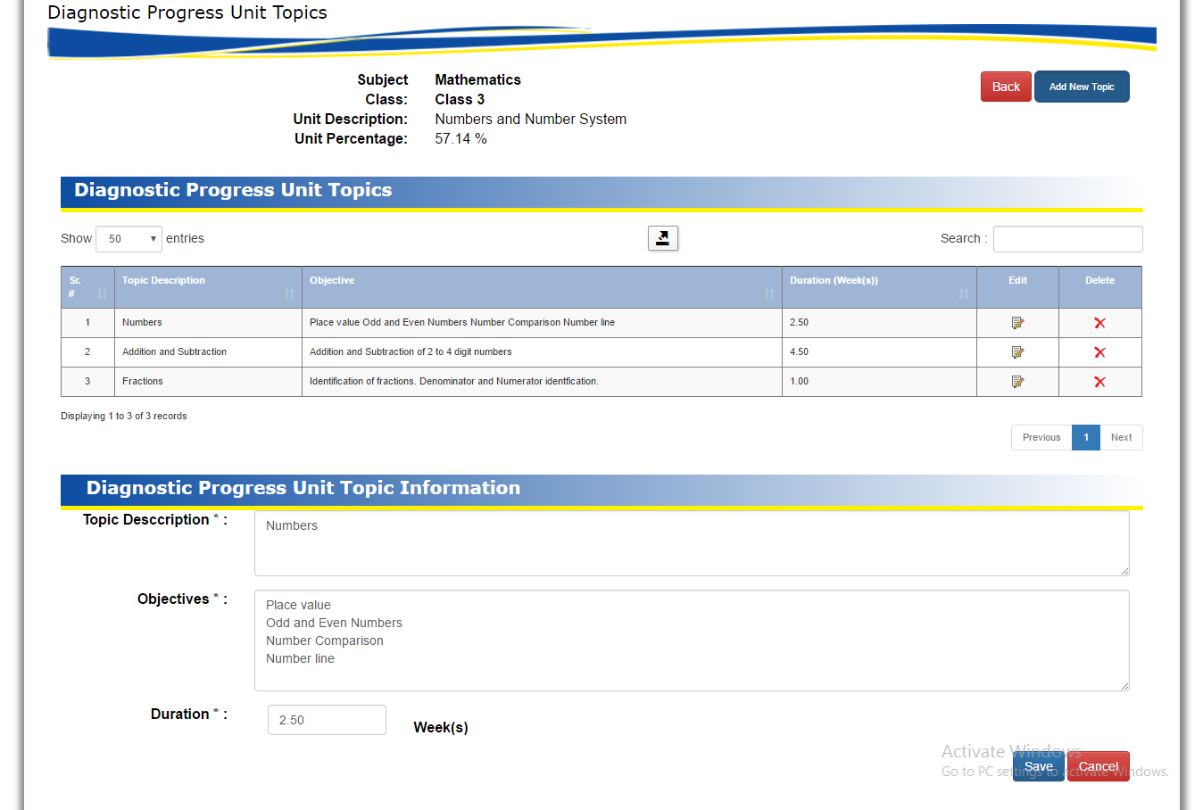

Diagnostic Progress 🡪 Table of Specifications

1. Click on the **Progress Checker 🡪 Progress Checker**

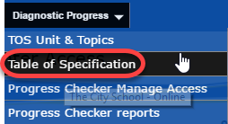

In this section HO User can Section and question

HO User will select

Class 🡪Subject🡪Term🡪Evaluation Criteria

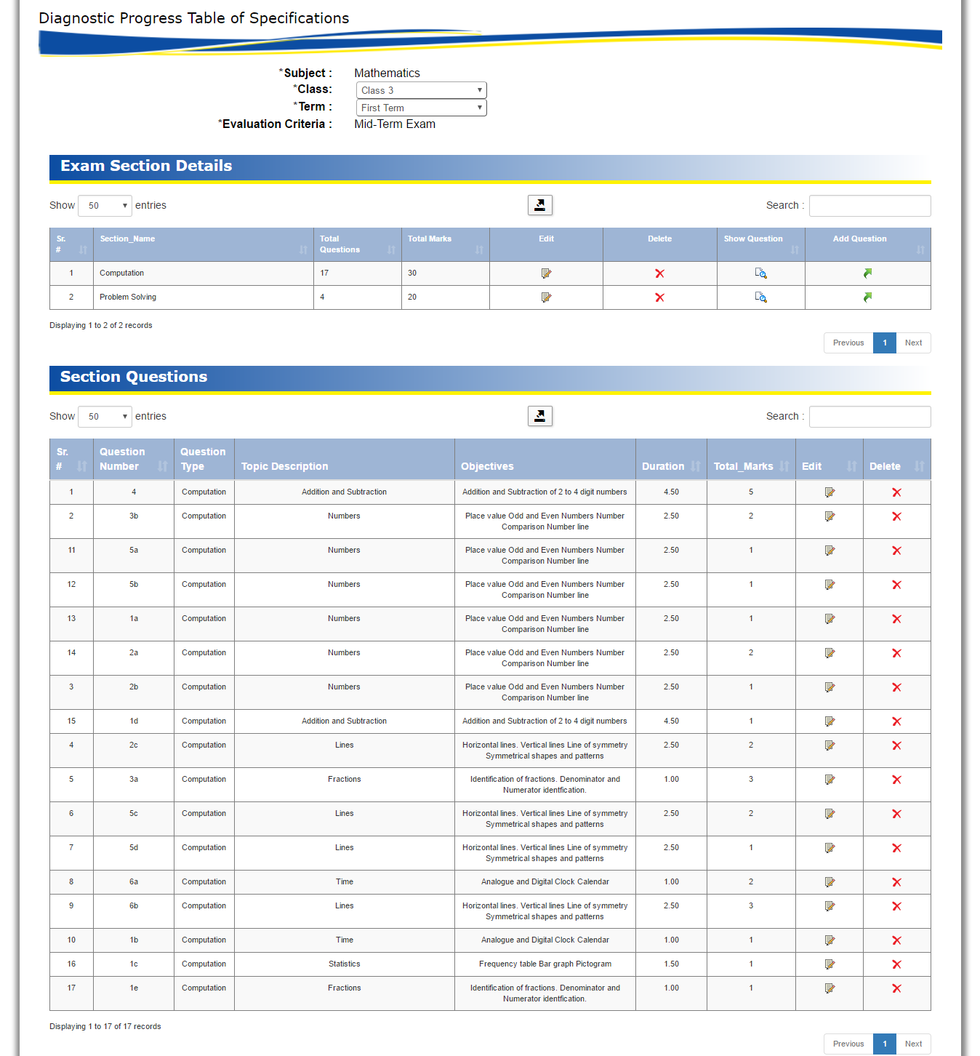

In this section HO user can add / update Section with topic and question type. And question type will be Objective and subjective. This Section will apply to all assign teachers for selected class and subjects.

Then next step is to add question of relevant section

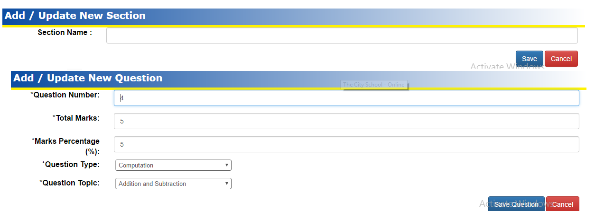

Using this option user can add questions to relevant section which will apply to selected class – subject assigned students

## Progress Checker 🡪 Manage Center Access

Progress Checker 🡪 Mange Center Access

1. Click on the **Progress Checker 🡪 Manage Center Access**

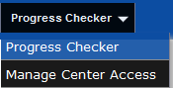

In this section HO User can assign rights to desired centers by selecting the region drop down which is highlighted in red

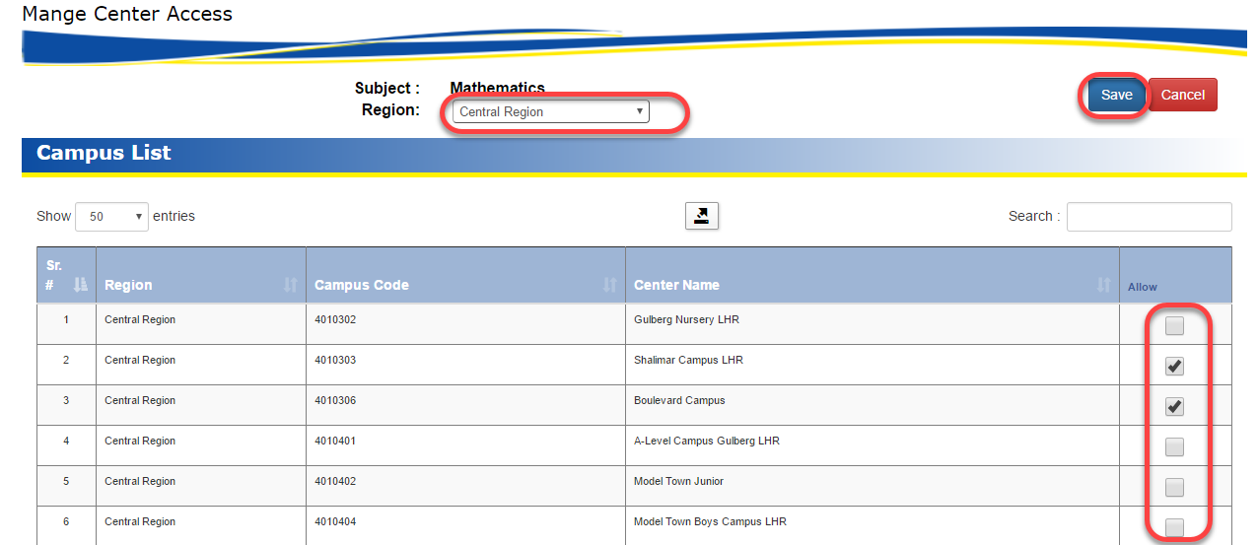

Ho User can use toggle check to maintain rights of section.